Capstone Project

**Course code:** CSA4385

**Course:** Internet Programming for Green App

**Team:** 02

**Name:**

S.vaishnavi

B.V.Bavana

**Registration no:**

192211575

192211331

**Slot:** B

**Title:** Travel Agency by using Icdi code

**Guided by:** Venkatesan sir

**Department:** CSE

**College:** Saveetha School of Engineering



**Objectives**

1. **Creating a niche**: Specializing in a specific area of travel expertise.
2. **Selling expertise**: Providing valuable knowledge and insider information to clients.
3. **Making travel planning and booking easier**: Offering convenience and access to exclusive deals.
4. **Building customer relationships**: Focusing on repeat business and customer satisfaction.
5. **Serving as a link between clients and suppliers**: Facilitating travel services and providing reliable information.

**6.Enhance Customer Experience:**

* + Provide personalized travel planning and booking services.
  + Offer 24/7 customer support to assist with travel issues and inquiries.
  + Ensure timely and accurate communication with clients regarding their bookings and travel plans.

**7.Expand Product and Service Offerings:**

* + Develop a diverse range of travel packages catering to different market segments (e.g., luxury, budget, adventure, family).
  + Include unique and exclusive experiences that set the agency apart from competitors.

**Business Growth and Market Expansion**

**1.Increase Market Share:**

* + Implement marketing campaigns to attract new customers.
  + Develop partnerships with airlines, hotels, and other travel service providers to offer competitive rates and packages.

**2.Expand Geographic Reach:**

* + Open new branches or establish partnerships in high-potential markets.
  + Promote destinations that are emerging as popular tourist spots.

**Operational Efficiency**

**3.Streamline Operations:**

* + Implement advanced booking and CRM systems to manage client information and bookings efficiently.
  + Optimize the use of technology to reduce manual processes and improve service deliver

**Keywords**

• Travel Agency

• Travel Agent

• Book Travel

• Vacation Packages

• Holiday Packages

• Travel Deals

• Travel Offers

• Travel Planner

• Travel Services

* **Introduction**

At [Your Travel Agency Name], we believe that travel is more than just visiting new places; it's about creating memories that last a lifetime. Whether you're dreaming of sun-soaked beaches, thrilling adventures, cultural explorations, or tranquil escapes, we are here to make those dreams a reality.

With years of experience and a passion for discovering the world's most captivating destinations, our team of dedicated travel experts is committed to providing personalized service and bespoke travel experiences. From the moment you contact us to the day you return home, we ensure every detail is meticulously planned and executed, so you can travel with confidence and peace of mind. **Tailored Itineraries:** We understand that every traveler is unique. That's why we offer customized travel plans that cater to your specific interests, preferences, and budget.

**Exclusive Deals:** Take advantage of our exclusive travel deals and packages, designed to give you the best value for your money without compromising on quality.

**Expert Guidance:** Our knowledgeable travel consultants are passionate about travel and are always on hand to offer expert advice and insider tips to enhance your travel experience.

**Comprehensive Services:** From flight bookings and hotel reservations to car rentals, guided tours, and travel insurance, we provide a full range of travel services to meet all your needs.

**24/7 Support:** Travel with peace of mind knowing that our support team is available around the clock to assist you with any questions or concerns during your trip. Discover the wonders of Europe, the exotic charm of Asia, the vibrant cultures of South America, the breathtaking landscapes of Africa, and the endless adventures awaiting you in every corner of the globe. Whether you're planning a romantic getaway, a family vacation, a solo adventure, or a group tour, [Your Travel Agency Name] is your trusted partner in crafting extraordinary travel experiences.

**ICDI Code:**

<!DOCTYPE html>

<html lang="en">

<head>

<meta charset="utf-8" />

<meta name="viewport" content="width=device-width, initial-scale=1.0" />

<title>TRAVEL AGENCY</title>

<link href="style.css" rel="stylesheet" />

<style>

/* CSS for Login and Register buttons */

a {

display: inline-block;

padding: 10px 20px;

margin: 10px;

background-color: #bb4545; /* Button background color */

color: #faf6f6; /* Text color */

text-decoration: none;

border-radius: 5px;

border: 2px solid;

transition: background-color 0.3s ease;

}

body {

background-color: rgb(245, 245, 247);

}

h1,

h2,

p {

text-align: center;

}

h2 {

font-size: 35px;

font-style: normal;

}

/* CSS for the "Explore Trips!" link */

a.explore-link {

color: #faf6f6; /* Default color */

text-decoration: none;

}

a.explore-link:hover {

color: #050505; /* Color on hover */

}

.btn-container {

text-align: center;

margin-bottom: 20px;

}

body {

font-family: Arial, sans-serif;

background-color: white;

margin: 0;

padding: 0;

}

.container {

width: 80%;

margin: 20px auto;

padding: 20px;

background-color: #d6d6a6;

border-radius: 10px;

box-shadow: 0 0 10px rgba(0, 0, 0, 0.1)

box-shadow: 0 0 10px rgba(0, 0, 0, 0.1);

}

h1 {

color: #bb4545;

text-align: center;

}

p {

font-size: 16px;

line-height: 1.6;

margin-bottom: 15px;

}

hr {

height: 10px;

border: 0;

box-shadow: 0 10px 10px -10px #8c8b8b inset;

}

nav {

display: flex;

justify-content: center;

padding: 10px 0;

background-color: rgb(204, 199, 105);

}

nav a {

text-decoration: none;

color: white;

padding: 10px 20px;

}

nav a:hover {

background-color: black;

color: white;

}

.contact-info {

display: flex;

justify-content: center;

margin-top: 30px;

}

.contact-item {

margin: 0 20px;

text-align: center;

}

.contact-item img {

width: 40px;

height: 40px;

margin-bottom: 10px;

}

.review-item {

margin: 0 20px;

text-align: center;

}

.review-item img {

width: 100px;

border-radius: 8px;

box-shadow: 0 0 5px rgba(0, 0, 0, 0.1);

}

.review-content {

flex: 1;

margin-top: 10px;

}

</style>

</head>

<body>

<div class="menu"></div>

<main>

<div align="center">

<h1>DREAMSCAPE TRAVELS</h1>

</div>

<div align="left">

<img

src="https://encrypted- <hr />

<div class="btn-container">

<nav>

<a href="about.html" style="margin-right: 30px">About</a>

<a href="#contact" style="margin-right: 300px">Contact</a>

<a href="signin.html" style="margin-right: 30px">SignIn</a>

<a href="register.html">Register</a>

</nav>

</div>

<hr />

<p>Est. 2024</p>

<div>

<img

src="https://act-on.com/wp-content/uploads/2020/06/travel-marketing.png"

style="

width: 800px;

height: 400px;

margin-left: 350px;

border-radius: 10px;

<div class="container" id="contact">

<h1>Contact Us</h1>

<div class="contact-info">

<div class="contact-item">

<img

src="https://img.icons8.com/material-rounded/24/000000/worldwide-location--v1.png"

/>

<p><strong>Address:</strong><br />123 Dream Street, Dreamland</p>

</div>

<div class="contact-item">

<img

src="https://img.icons8.com/material-rounded/24/000000/phone--v1.png"

/>

<p><strong>Phone:</strong><br />+1 (123) 456-7890</p>

</div>

<div class="contact-item">

<img

src="https://img.icons8.com/material-rounded/24/000000/email--v1.png"

/>

<p><strong>Email:</strong><br />info@dreamscapetravels.com</p>

</div>

</div>

</div>

<br />

<hr />

<br /><br />

<h1>Customer Reviews</h1>

<br /><br />

<ul

style="

list-style: none;

display: flex;

justify-content: space-around;

padding: 0;

"

> <li class="review-item">

<img

* OUTPUT:

<!DOCTYPE html>

<html lang="en">

<head>

  <meta charset="UTF-8">

  <meta name="viewport" content="width=device-width, initial-scale=1.0">

  <title>Pet Adoption</title>

  <link rel="stylesheet" href="styles.css">

</head>

<body>

  <header>

    <h1>Pet Adoption</h1>

    <nav>

      <ul>

        <li><a href="index.html">Home</a></li>

        <li><a href="pets.html">View Pets</a></li>

        <li><a href="contact.html">Contact</a></li>

      </ul>

    </nav>

  </header>

  <div class="hero">

    <img src="cat.jpeg" alt="Pet Adoption" class="hero-image">

    <img src="pet1.jpeg" alt="Pet Adoption" class="hero-image">

    <h2>Welcome to our Pet Adoption Website</h2>

    <p>Find your new furry friend today!</p>

  </div>

  <footer>

    <p>&copy; 2024 Pet Adoption</p>

  </footer>

</body>

</html>

* **OUTPUT:**

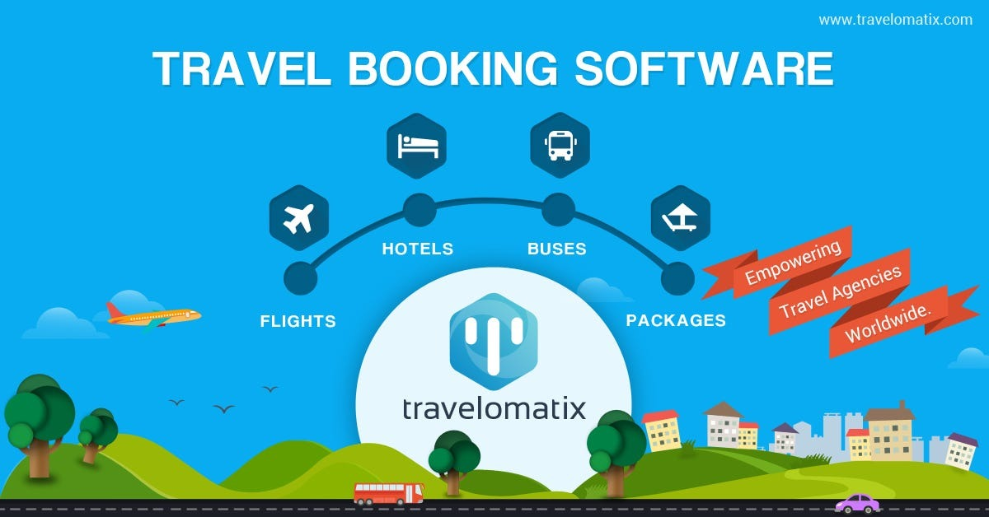

* **TRAVEL AGENCY IN JAVA CODE :**

public class Trip {

private String destination;

private double price;

private boolean booked;

public Trip(String destination, double price) {

this.destination = destination;

this.price = price;

this.booked = false;

}

public String getDestination() {

return destination;

}

public void setDestination(String destination) {

this.destination = destination;

}

public double getPrice() {

return price;

}

public void setPrice(double price) {

this.price = price;

}

public boolean isBooked() {

return booked;

}

public void bookTrip() {

this.booked = true;

}

@Override

public String toString() {

return "Trip{destination='" + destination + "', price=" + price + ", booked=" + booked + "}";

}

}

* **OUTPUT:**

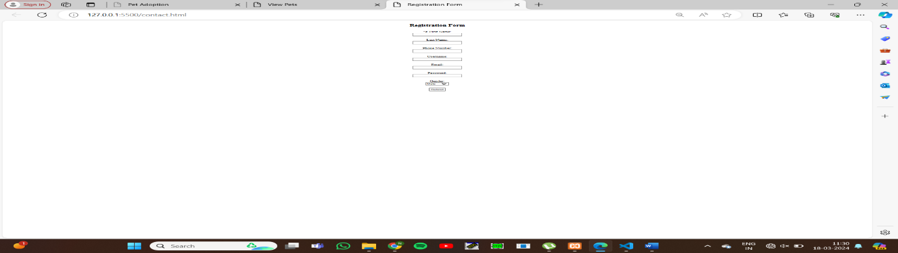

* **ICDI DATA BASE CODE:**

<!DOCTYPE html>

<html>

<head>

    <title>Registration Form</title>

</head>

<body>

    <center>

    <h2>Registration Form</h2>

    <form method="post" action="<?php echo htmlspecialchars($_SERVER["PHP_SELF"]); ?>">

        <input type="hidden" name="action" value="submit_registration">

        <label for="firstname">First Name:</label><br>

        <input type="text" id="firstname" name="firstname"><br><br>

        <label for="lastname">Last Name:</label><br>

        <input type="text" id="lastname" name="lastname"><br><br>

        <label for="phonenumber">Phone Number:</label><br>

        <input type="text" id="phonenumber" name="phonenumber"><br><br>

        <label for="username">Username:</label><br>

        <input type="text" id="username" name="username"><br><br>

        <label for="email">Email:</label><br>

        <input type="email" id="email" name="email"><br><br>

        <label for="password">Password:</label><br>

        <input type="password" id="password" name="password"><br><br>

        <label for="gender">Gender:</label><br>

        <select id="gender" name="gender">

            <option value="male">Male</option>

            <option value="female">Female</option>

            <option value="other">Other</option>

        </select><br><br>

        <input type="submit" value="Submit">

    </form>

    </center>

    <?php

    $servername = "localhost";

    $username = "root";

    $password = "";

    $dbname = "pet";

    $conn = new mysqli($servername, $username, $password, $dbname);

    if ($conn->connect_error) {

        die("Connection failed: " . $conn->connect_error);

    }

    if (isset($_POST['action']) && $_POST['action'] == 'submit_registration') {

        $firstname = isset($_POST['firstname']) ? $conn->real_escape_string($_POST['firstname']) : '';

        $lastname = isset($_POST['lastname']) ? $conn->real_escape_string($_POST['lastname']) : '';

        $phonenumber = isset($_POST['phonenumber']) ? $conn->real_escape_string($_POST['phonenumber']) : '';

        $username = isset($_POST['username']) ? $conn->real_escape_string($_POST['username']) : '';

        $email = isset($_POST['email']) ? $conn->real_escape_string($_POST['email']) : '';

        $password = isset($_POST['password']) ? $conn->real_escape_string($_POST['password']) : '';

        $gender = isset($_POST['gender']) ? $conn->real_escape_string($_POST['gender']) : '';

        $sql = "INSERT INTO details(firstname, lastname, phonenumber, username, email, password, gender)

                VALUES ('$firstname', '$lastname', '$phonenumber', '$username', '$email', '$password', '$gender')";

        if ($conn->query($sql) === TRUE) {

            echo "Records inserted successfully.";

        } else {

            echo "ERROR: Could not able to execute $sql. " . $conn->error;

        }

    }

    $conn->close();

    ?>

</body>

</html>

* **OUTPUT:**

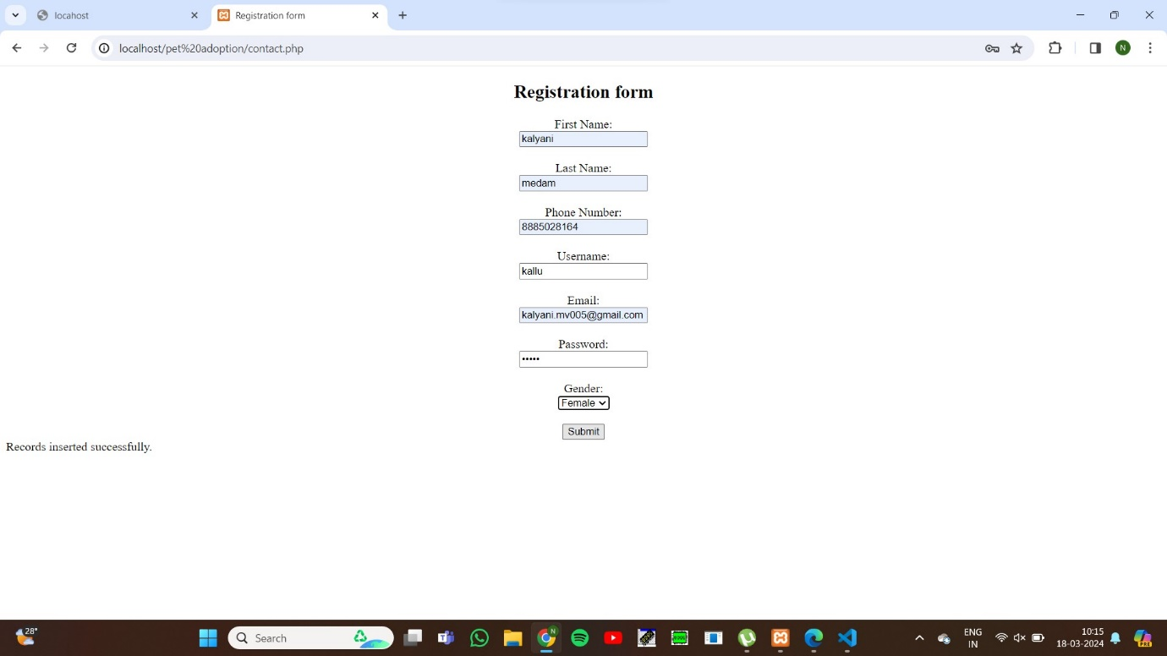

* **STYLE SHEET CSS:**

body {

    font-family: Arial, sans-serif;

    margin: 0;

    padding: 0;

  }

  header {

    background-color: #333;

    color: white;

    padding: 20px;

    text-align: center;

  }

  nav ul {

    list-style-type: none;

    padding: 0;

  }

  nav ul li {

    display: inline;

    margin-right: 20px;

    background-color:wheat;

    padding: 10px;

    border-radius: 20px;

    text-decoration-color: black;

  }

  .hero {

    background-image: url('background.jpeg');

    background-size: cover;

    color: white;

    text-align: center;

    padding: 100px 0;

  }

  footer {

    background-color: #333;

    color: white;

    padding: 10px 0;

    text-align: center;

  }

  .contact-form {

    margin: 20px auto;

    width: 50%;

  }

  .contact-form form {

    border: 1px solid #ccc;

    padding: 20px;

  }

  .contact-form label {

    display: block;

    margin-bottom: 5px;

  }

  .contact-form input[type="text"],

  .contact-form input[type="email"],

  .contact-form textarea {

    width: 100%;

    margin-bottom: 10px;

  }

  .contact-form button {

    background-color: #333;

    color: white;

    border: none;

    padding: 10px 20px;

    cursor: pointer;

  }

  .contact-form button:hover {

    background-color: #555;

  }

* **OUTPUT:**



* **CONCLUSION:**

Explore our diverse range of travel packages and services, designed to suit every taste and budget. Our team of passionate travel consultants is ready to provide you with expert advice and ensure that every detail of your trip is flawlessly executed.Join the countless travelers who have experienced the world with [Your Travel Agency Name] and discovered the true joy of travel. Your next adventure is just a call or click away.